NIMS - The Incident Command System

The Incident Command System (ICS) is the combination of facilities, equipment, personnel, procedures, and communications operating within a common organizational structure, designed to aid in domestic incident management activities. It is used for a broad spectrum of emergencies, from small to complex incidents, both natural and manmade, including acts of catastrophic terrorism. ICS is used by all levels of government—Federal, State, local, and tribal, as well as by many private-sector and nongovernmental organizations. ICS is usually organized around five major functional areas: command, operations, planning, logistics, and finance and administration. A sixth functional area, Intelligence, may be established if deemed necessary by the Incident Commander, depending on the requirements of the situation at hand.

Some of the more important “transitional steps” that are necessary to apply ICS in a field incident environment include the following:
- recognizing and anticipating the requirement that organizational elements will be activated and taking the necessary steps to delegate authority as appropriate;
- establishing incident facilities as needed, strategically located, to support field operations;
- establishing the use of common terminology for organizational functional elements, position titles, facilities, and resources; and
- rapidly evolving from providing oral direction to the development of a written Incident Action Plan.
NIMS - ICS Organization

A. FUNCTIONAL STRUCTURE.
The ICS organization comprises five major functional areas (Figure A-1): command, operations, planning, logistics, and finance and administration. (A sixth area, intelligence, may be established if required.)

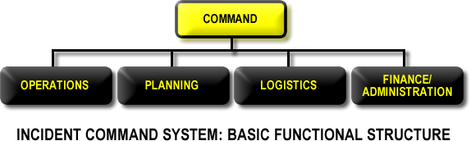
Figure A-1

B. MODULAR EXTENSION.
The ICS organizational structure is modular, extending to incorporate all elements necessary for the type, size, scope, and complexity of a given incident. The IC structural organization builds from the top down; responsibility and performance begin with the incident command element and the IC. When the need arises, four separate sections can be used to organize the staff. Each of these may have several subordinate units, or branches, depending on the management requirements of the incident. If one individual can simultaneously manage all major functional areas, no further organization is required. If one or more of the functions requires independent management, an individual is assigned responsibility for that function.
The responding IC’s initial management assignments will normally be one or more Section Chiefs to manage the major ICS functional areas (operations, planning, logistics, and finance and administration). The Section Chiefs will further delegate management authority for their areas as required. If a Section Chief sees the need, he or she may establish branches or units (depending on the section). Similarly, each functional unit leader will further assign individual tasks within the unit as needed.

The modular concept described above is based on the following considerations:
- developing the form of the organization to match the function or task to be performed;
- staffing only the functional elements that are required to perform the task;
- observing recommended span-of-control guidelines;
- performing the function of any non-activated organizational element at the next highest level; and
- deactivating organizational elements no longer required.

For reference, Table A-1 describes the distinctive title assigned to each element of the ICS organization at each corresponding level, as well as the leadership title corresponding to each individual element.

Organizational Element
Leadership Position

Incident Command | Incident Commander (IC)

Command Staff | Officer

Section | Section Chief

Branch | Branch Director

Division and Groups* | Supervisors

Unit** | Unit Leader

*The hierarchical term supervisor is only used in the Operations Section.
**Unit leader designations apply to the subunits of the Planning, Logistics, and Finance/Administration Sections.

NIMS - The Operations Section

The Operations Section is responsible for managing tactical operations at the incident site directed toward reducing the immediate hazard, saving lives and property, establishing situation control, and restoring normal conditions. Incidents can include acts of terrorism, wild land and urban fires, floods, hazardous material spills, nuclear accidents, aircraft accidents, earthquakes, hurricanes, tornadoes, tropical storms, war-related disasters, public health and medical emergencies, and other incidents requiring an emergency response.
Because of its functional unit management structure, the ICS is applicable across a spectrum of incidents differing in size, scope, and complexity. The types of agencies that could be included in the Operations Section include fire, law enforcement, public health, public works, and emergency services, working together as a unit or in combinations, depending on the situation. Many incidents may involve private individuals, companies, or nongovernmental organizations, some of which may be fully trained and qualified to participate as partners in the Operations Section.
Incident operations can be organized and executed in many ways. The specific method selected will depend on the type of incident, agencies involved, and objectives and strategies of the incident management effort. The following discussion presents several different methods of organizing incident tactical operations. In some cases, a method will be selected to accommodate jurisdictional boundaries. In other cases, the approach will be strictly functional. In still others, a mix of functional and geographical approaches may be appropriate. The ICS offers extensive flexibility in determining the appropriate approach using the factors described above. Figure 2-A shows the primary organizational structure within the Operations Section.

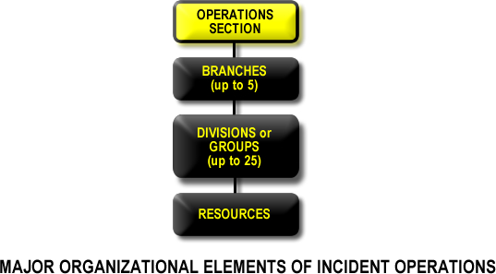
Figure 2-A
A. OPERATIONS SECTION CHIEF.
The Operations Section Chief directly manages all incident tactical activities and implements the IAP. The Operations Section Chief may have one or more deputies (preferably from other agencies in multi-jurisdictional incidents). Deputies will be qualified to a similar level as the Operations Section Chief. An Operations Section Chief should be designated for each operational period and will have direct involvement in the preparation of the IAP for the period of responsibility.

B. DIVISIONS and GROUPS.
Divisions and groups are established when the number of resources exceeds the Operations Section Chief’s manageable span of control. Divisions demarcate physical or geographical areas of operation within the incident area. Groups demarcate functional areas of operation for the incident. See Figure 2-B.
The use of the two terms is necessary, because division always refers to a geographical assignment and group always refers to a functional assignment. Both divisions and groups may be used in a single incident if there is justification for their use and if proper coordination can be effected.
As additional types of resources are added to the organization, resources should be assigned into a division structure. See Figure 2-C.

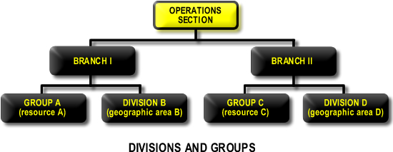
Figure 2-B

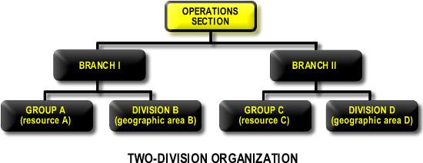
Figure 2-C

- Geographical Divisions.
The best way to create geographical divisions is to divide an area according to natural separations of terrain or other prominent geographical features, such as rivers. When geographical features are used for determining boundaries, the size of the division should correspond to appropriate span-of-control guidelines. See Figure 2-D.
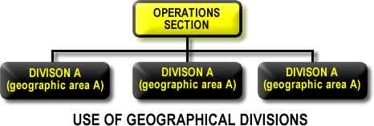
Figure 2-D
- Functional Groups.
Functional groups can best be used to describe areas of like activity (e.g., rescue, evacuation, medical). See Figure 2-E.
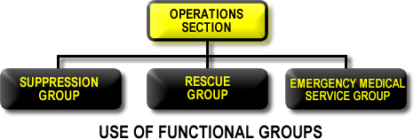
Figure 2-E
3. Combined Geographical Divisions and Functional Groups.
It is also possible to have both divisions and groups within the Operations Section. For example, Divisions A, B, and C (based on jurisdictional boundaries) might each have two groups, 1 and 2, to provide a management structure for different types of resources within that division.

C. RESOURCE ORGANIZATION.
Initially, in any incident, individual resources that are assigned will report directly to the IC. As the incident grows in size or complexity, individual resources may be organized and employed in a number of ways to facilitate incident management:

- Single Resources.
Resources may be employed on an individual basis. This is typically the case in the context of the initial response to the incident. During sustained operations, situations will typically arise that call for the use of a single helicopter, vehicle, mobile equipment, etc.
- Task Forces.
Task Forces are any combination of resources put together to accomplish a specific mission. Task Forces have a designated leader and operate with common communications. Combining resources into Task Forces allows several key resource elements to be managed under one individual’s supervision, thus aiding in span of control.
- Strike Teams.
A Strike Team consists of a set number of resources of the same kind and type operating under a designated leader with common communications between them. Strike Teams represent known capability and are highly effective management units.

D. BRANCHES.
Branches may be established to serve several purposes including the following:
- The Numbers of Divisions and/or Groups Exceed the Recommended Span of Control for the Operations Section Chief.
The recommended span of control for the Operations Section Chief is 1:5 (or as high as 1:10 for larger-scale law enforcement operations).When this is exceeded, the Operations Section Chief should set up two branches (see Figure 2-F), allocating the divisions and groups between them. For example, if one group and four divisions
are reporting to the Operations Section Chief, and two divisions and one group are to be added, a two-branch organization should be formed.
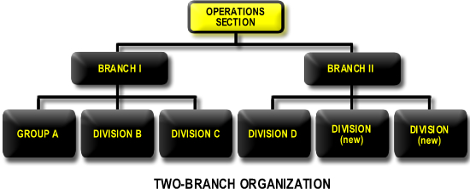
Figure 2-F
2. The Nature of the Incident Calls for a Functional Branch Structure.
For example, if a large aircraft crashes within a city, various departments within the city (including police, fire, emergency services, and public health services) would each have a functional branch operating under the direction of a single Operations Section Chief. In this example (see Figure 2-G), the Operations Section Chief is from the fire department, with deputies from police and public health services. Other alignments could be made, depending on the city plan and type of emergency. Note that, in this situation, the Incident Command could be either a single command or Unified Command (UC), depending on the jurisdiction.

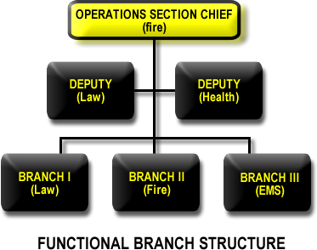
Figure 2-G
3. The Incident is Multi-jurisdictional.
In this case, resources are best managed under the agencies that normally control them (see Figure 2-H). For example, the response to a major flood might require combining Federal, State, county, city, and tribal resources.
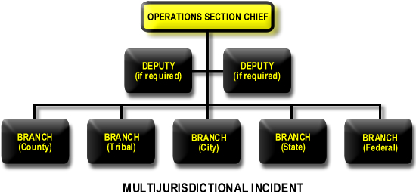
Figure 2-H
E. AIR OPERATIONS BRANCH.
The Operations Section Chief may establish an Air Operations Branch to meet mission requirements in certain situations, in which size, organization, and operation will depend primarily on the nature of the incident and the availability of air assets.* Figure 2-I shows a typical organizational structure for air operations.
The Operations Section Chief may designate a director for the Air Operations Branch when the complexity of air operations requires additional support and effort or when the incident requires mixing tactical and logistical utilization of helicopters and other aircraft. Flight safety is a paramount concern in complex operations and supports the requirement for a designated Air Operations Branch to ensure the deconfliction of assets and the integration of safety considerations into operational planning and mission execution. Whenever both helicopters and fixed-wing aircraft must operate simultaneously within the incident air space, a Air Tactical Group Supervisor should be designated. This individual coordinates all airborne activity with the assistance of a helicopter coordinator and a fixed-wing coordinator. When only one helicopter is used, however, the helicopter may be directly under the control of the Operations Section Chief.
The Air Support Group establishes and operates bases for rotary-wing air assets and maintains required liaison with off-incident fixed-wing bases. The Air Support Group is responsible for all timekeeping for aviation assets assigned to the incident.
* Air Operations Branch is used here as an example and may not be applicable to all ICS organizations.
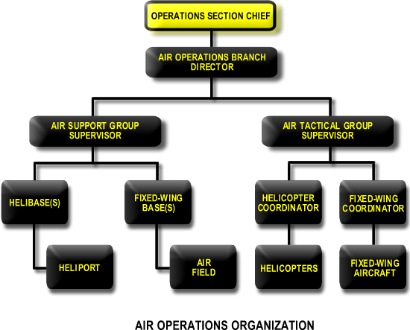
Figure 2-I

NIMS - The Planning Section

The Planning Section is responsible for collecting, evaluating, and disseminating tactical information pertaining to the incident. This section maintains information and intelligence on the current and forecasted situation, as well as the status of resources assigned to the incident. The Planning Section prepares and documents IAPs and incident maps and gathers and disseminates information and intelligence critical to the incident. As shown in Figure 3-A, the Planning Section has four primary units and may include a number of technical specialists to assist in evaluating the situation and forecasting requirements for additional personnel and equipment.

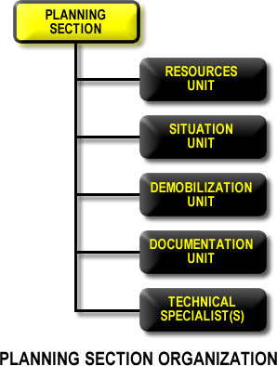
Figure 3-A
A. PLANNING SECTION CHIEF.
The Planning Section Chief oversees all incident-related data gathering and analysis regarding incident operations and assigned resources, develops alternatives for tactical operations, conducts planning meetings, and prepares the IAP for each operational period. This individual will normally come from the jurisdiction with primary incident responsibility and may have one or more deputies from other participating jurisdictions.

B. RESOURCES UNIT.
1. Responsibilities.
Physical resources consist of personnel, teams, facilities, supplies, and major items of equipment available for assignment to or employment during incidents. The Resources Unit makes certain that all assigned personnel and other resources have checked in at the incident. This unit should have a system for keeping track of the current location and status of all assigned resources and should maintain a master list of all resources committed to incident operations.
2. Managing Resources.
For effective management of their employment, resources must be categorized by capability and capacity across disciplines and tracked continuously as to status. The following tools are necessary for maintaining an up-to-date and accurate picture of resource utilization:
a. Status Conditions.
Tactical resources at an incident can have one of three status conditions:
- Assigned resources are personnel, teams, equipment, or facilities that have checked in (or in the case of equipment and facilities, receipted for) and are supporting incident operations.
- Available resources are personnel, teams, equipment, or facilities that have been assigned to an incident and are ready for a specific work detail or function.
- Out-of-service resources are personnel, teams, equipment, or facilities that have been assigned to an incident but are unable to function for mechanical, rest, or personal reasons; or because their condition makes them unusable.
- Changes in Status.
Normally, the individual who changes the status of a resource, such as equipment location and status, is responsible for promptly informing the Resources Unit.

C. SITUATION UNIT.
The Situation Unit collects, processes, and organizes ongoing situation information; prepares situation summaries; and develops projections and forecasts of future events related to the incident. The Situation Unit also prepares maps and gathers and disseminates information and intelligence for use in the IAP. This unit may also require the expertise of technical specialists and operations and information security specialists.

D. DOCUMENTATION UNIT.
The Documentation Unit maintains accurate and complete incident files, including a complete record of the major steps taken to resolve the incident; provides duplication services to incident personnel; and files, maintains, and stores incident files for legal, analytical, and historical purposes. Documentation is part of the Planning Section primarily because this unit prepares the IAP and maintains many of the files and records that are developed as part of the overall IAP and planning function.

E. DEMOBILIZATION UNIT.
The Demobilization Unit develops an Incident Demobilization Plan that includes specific instructions for all personnel and resources that will require demobilization. This unit should begin its work early in the incident, creating rosters of personnel and resources and obtaining any missing information as check-in proceeds.
Note that many city- and county-provided resources, because they are local, do not require specific demobilization instructions. Once the Incident Demobilization Plan has been approved, the Demobilization Unit ensures that it is distributed both at the incident and elsewhere as necessary.

F. TECHNICAL SPECIALISTS.
The ICS is designed to function in a wide variety of incident scenarios requiring the use of technical specialists. These personnel have special skills and are activated only when needed. Specialists may serve anywhere within the organization, including the Command Staff. No minimum qualifications are prescribed, as technical specialists normally perform the same duties during an incident that they perform in their everyday jobs, and they are typically specially certified in their fields or professions.
Technical specialists assigned to the Planning Section may report directly to its chief, may report to any function in an existing unit, or may form a separate unit within the Planning Section, depending on the requirements of the incident and the needs of the Section Chief. Technical specialists may also be assigned to other parts of the organization (e.g., to the Operations Section to assist with tactical matters or to the Finance/Administration Section to assist with fiscal matters). For example, a legal specialist or legal counsel may be assigned directly to the Command Staff to advise the IC on legal matters, such as emergency proclamations, legality of evacuation orders, and legal rights and restrictions pertaining to media access. Generally, if the expertise is needed for only a short period and normally involves only one individual, that individual should be assigned to the Situation Unit. If the expertise will be required on a long-term basis and may require several personnel, it is advisable to establish a separate Technical Unit in the Planning Section.
The incident itself will primarily dictate the needs for technical specialists. Below are representative examples of the kinds of specialists that may be required:
- Meteorologist
- environmental impact specialist
- resource use and cost specialists
- flood control specialist
- water-use specialist
- explosives specialist
- structural engineering specialist
- firefighter specialist
- medical and/or health care specialist
- medical intelligence specialist
- pharmaceutical specialist
- veterinarian
- agricultural specialist
- toxic substance specialist
- radiation health physicist
- intelligence specialist
- infectious disease specialist
- chemical or radiological decontamination specialist
- law enforcement specialist
- attorney or legal counsel
- industrial hygienist
- transportation specialist
- scientific support coordinator

A specific example of the need to establish a distinct technical unit within the General Staff is the requirement to coordinate and manage large volumes of environmental sampling and/or analytical data from multiple sources in the context of certain complex incidents, particularly those involving biological, chemical, and radiation hazards. To meet this requirement, an Environmental Unit could be established within the Planning Section to facilitate interagency environmental data management, monitoring, sampling, analysis, and assessment. The Environmental Unit would prepare environmental data for the Situation Unit and work in close coordination with other units and sections within the ICS structure to enable effective decision support to the IC or UC. Technical Specialists assigned to the Environmental Unit might include a Scientific Support Coordinator and Sampling, Response Technologies, Weather Forecast, Resources at Risk, Cleanup Assessment, and Disposal Technical Specialists. Example tasks accomplished by the Environmental Unit would include the following:
- identifying sensitive areas and recommending response priorities;
- developing a plan for collecting, transporting, and analyzing samples;
- providing input on wildlife protection strategies;
- determining the extent and effects of site contamination;
- developing site cleanup and hazardous material disposal plans; and
- identifying the need for and obtaining permits and other authorizations.

NIMS - The Logistics Section

The Logistics Section meets all support needs for the incident, including ordering resources through appropriate procurement authorities from off-incident locations. It also provides facilities, transportation, supplies, equipment maintenance and fueling, food service, communications, and medical services for incident personnel. See Figure 4-A. The Logistics Section is led by a Section Chief, who may also have a deputy. Having a deputy is encouraged when all designated units are established at an incident site. When the incident is very large or requires a number of facilities with large numbers of equipment, the Logistics Section can be divided into two branches (Figure 4-B provides an example).
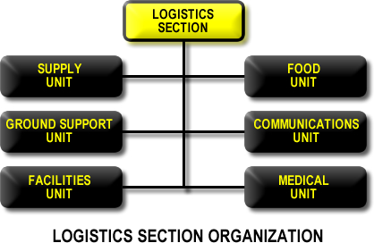
Figure 4-A

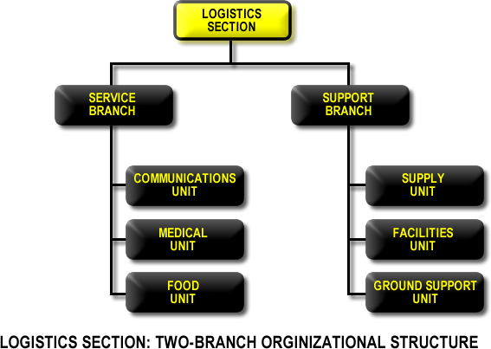
Figure 4-B
A. SUPPLY UNIT.
The Supply Unit orders, receives, stores, and processes all incident-related resources, personnel, and supplies.
Once established, the Supply Unit also has the basic responsibility for all off-incident ordering, including
- all tactical and support resources (including personnel)
- all expendable and nonexpendable supplies required for incident support.
The Supply Unit provides the support required to receive, process, store, and distribute all supply orders. The unit also handles tool operations, which include storing, disbursing, and servicing of all tools and portable, nonexpendable equipment.

B. FACILITIES UNIT.
The Facilities Unit sets up, maintains, and demobilizes all facilities used in support of incident operations. The unit also provides facility maintenance and security services required to support incident operations.
The Facilities Unit sets up the ICP, incident base, and camps, as well as trailers and/or other forms of shelter for use in and around the incident area. The incident base and camps may often be established in areas having existing structures, which may be used in their entirety or only in part. The Facilities Unit also provides and sets up necessary personnel support facilities, including areas for:
- food and water service;
- sleeping;
- sanitation and showers; and
- staging.
This unit also orders, through supply, such additional support items as portable toilets, shower facilities, and lighting units.
Note that providing shelter for victims is a critical operational activity, which will be incorporated into the IAP. Sheltering will normally be conducted by appropriate nongovernmental organization staff, such as the American Red Cross or other similar entities.

C. GROUND SUPPORT UNIT.
The Ground Support Unit
- maintains and repairs primary tactical equipment, vehicles, and mobile ground support equipment;
- records usage time for all ground equipment (including contract equipment) assigned to the incident;
- supplies fuel for all mobile equipment; provides transportation in support of incident operations (except aircraft); and
- develops and implements the Incident Traffic Plan.
In addition to its primary functions of maintaining and servicing vehicles and mobile equipment, the Ground Support Unit also maintains a transportation pool for major incidents. This pool consists of vehicles (e.g., staff cars, buses, pick-ups) that are suitable for transporting personnel. The Ground Support Unit also provides up-to-date information on the location and status of transportation vehicles to the Resources Unit.

D. COMMUNICATIONS UNIT.
The Communications Unit develops the Communications Plan (ICS205) to make the most effective use of the communications equipment and facilities assigned to the incident, installs and tests all communications equipment, supervises and operates the incident communications center, distributes and recovers communications equipment assigned to incident personnel, and maintains and repairs communications equipment on site.
The Communications Unit’s major responsibility is effective communications planning for the ICS, especially in the context of a multiagency incident. This is critical for determining required radio nets, establishing interagency frequency assignments, and ensuring the interoperability and the optimal use of all assigned communications capabilities.
The Communications Unit Leader should attend all incident-planning meetings to ensure that the communication systems available for the incident can support tactical operations planned for the next operational period.
Incident communications are managed through the use of a common communications plan and an incident-based communications center established solely for the use of tactical and support resources assigned to the incident.
Advance planning is required to ensure that an appropriate communications system is available to support incident operations requirements. This planning includes the development of frequency inventories, frequency-use agreements, and interagency radio caches.
Most complex incidents will require an Incident Communications Plan. The Communications Unit is responsible for planning the use of radio frequencies; establishing networks for command, tactical, support, and air units; setting up on-site telephone and public address equipment; and providing any required off-incident communication links. Codes should not be used for radio communication; a clear spoken message—based on common terminology that avoids misunderstanding in complex and noisy situations—reduces the chances for error.
Radio networks for large incidents will normally be organized as follows:
- Command-Net.
Links together: incident command, command staff, section chiefs, branch directors, division, and group supervisors.
- Tactical-Nets.
Several tactical nets may be established to connect agencies, departments, geographical areas, or specific functional units. The determination of how nets are set up should be a joint planning, operation, and logistics function. The Communications Unit Leader will develop the overall plan.
- Support-Net.
A support net may be established primarily to handle changes in resource status but also to handle logistical requests and other non-tactical functions.
- Ground-to-Air Net.
To coordinate ground-to-air traffic, either a specific tactical frequency may be designated, or regular tactical nets may be used.
- Air-to-Air Nets.
Air-to-air nets will normally be pre-designated and assigned for use at the incident.

E. FOOD UNIT.
The Food Unit determines food and water requirements; plans menus, orders food, provides cooking facilities, cooks, serves, maintains food service areas, and manages food security and safety concerns.
Efficient food service is important, but especially so for any extended incident. The Food Unit must be able to anticipate incident needs, both in terms of the number of people who will need to be fed and whether the type, location, or complexity of the incident indicates that there may be special food requirements. The unit must supply food needs for the entire incident, including all remote locations (i.e., camps and staging areas), as well as supply food service to operations personnel unable leave operational assignments. The Food Unit must interact closely with the following elements:
- Planning Section, to determine the number of personnel that must be fed;
- Facilities Unit, to arrange food-service areas;
- Supply Unit, to order food;
- Ground Support Unit, to obtain ground transportation; and
- Air Operations Branch Director, to obtain air transportation.
Careful planning and monitoring is required to ensure food safety before and during food service operations, including the assignment, as indicated, of public health professionals with expertise in environmental health and food safety.
Note that feeding victims is a critical operational activity, which will be incorporated into the IAP. Feeding activities will normally be conducted by members of an appropriate nongovernmental organization, such as the American Red Cross or similar entities.

F. MEDICAL UNIT.
The primary responsibilities of the Medical Unit include the following:
- develop the Incident Medical Plan (for incident personnel);
- develop procedures for handling any major medical emergency involving incident personnel;
- provide continuity of medical care, including vaccinations, vector control, occupational health, prophylaxis, and mental health services for incident personnel;
- provide transportation for injured incident personnel;
- ensure that incident personnel patients are tracked as they move from origin, to care facility, to final disposition;
- assist in processing all paperwork related to injuries or deaths of incident assigned personnel; and
- coordinate personnel and mortuary affairs for incident personnel fatalities.
The Medical Unit is responsible for the effective and efficient provision of medical services to incident personnel. The Medical Unit Leader will develop a medical plan, which will, in turn, form part of the IAP. The medical plan should provide specific information on medical assistance capabilities at incident locations, potential hazardous areas or conditions, and off-incident medical assistance facilities and procedures for handling complex medical emergencies. The Medical Unit will also assist the Finance/Administration Section with the administrative requirements related to injury compensation, including obtaining written authorizations, billing forms, witness statements, administrative medical documents, and reimbursement as required. The Medical Unit will ensure patient privacy to the fullest extent possible.
Note that patient care and medical services for those who are not incident personnel
(victims of a bioterror attack, hurricane victims, etc.) are critical operational activities associated with a host of potential incident scenarios. As such, these activities are incorporated into the IAP as key considerations of the Plans and Operations Sections. These sections should be staffed accordingly with appropriately qualified Emergency Medical Services public health, medical personnel, technical experts, and other professional personnel, as required.

NIMS - The Finance/Administration Section

When there is a specific need for financial, reimbursement (individual and agency or department), and/or administrative services to support incident management activities, a Finance/Administration Section is established. Under the ICS, not all agencies will require such assistance. In large, complex scenarios involving significant funding originating from multiple sources, the Finance/Administrative Section is an essential part of the ICS. In addition to monitoring multiple sources of funds, the Section Chief must track and report to the IC the financial “burn rate” as the incident progresses. This allows the IC to forecast the need for additional funds before operations are affected negatively. This is particularly important if significant operational assets are under contract from the private sector. The Section Chief may also need to monitor cost expenditures to ensure that statutory rules that apply are met. Close coordination with the Planning Section and Logistics Section is also essential so that operational records can be reconciled with financial documents. Note that, in some cases, only one specific function may be required (e.g., cost analysis), which a technical specialist in the Planning Section could provide. Figure 5-A illustrates the basic Finance/Administration Section organizational structure. The Finance/Administration Section Chief will determine, given current and anticipated future requirements, the need for establishing specific subordinate units. In some of the functional areas (e.g., procurement), an actual unit need not be established if it would consist of only one person. In such a case, a procurement technical specialist would be assigned in the Planning Section instead. Because of the specialized nature of finance functions, the Section Chief should come from the agency that has the greatest requirement for this support. The Section Chief may have a deputy.
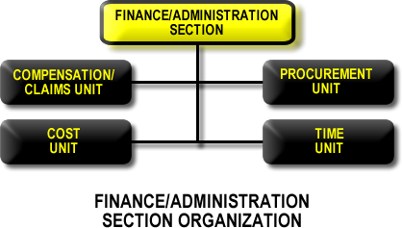
Figure 5-A

TIME UNIT.
The Time Unit is primarily responsible for ensuring proper daily recording of personnel time, in accordance with the policies of the relevant agencies. The Time Unit also ensures that the Logistics Section records or captures equipment usage time, through the Ground Support Unit for ground equipment and through the Air Operations Support Group for aircraft.
If applicable (depending on the agencies involved), personnel time records will be collected and processed for each operational period. The unit leader may require the assistance of personnel familiar with the relevant policies of any affected agencies. These records must be verified, checked for accuracy, and posted according to existing policies. Excess hours worked must also be determined, for which separate logs must be maintained.

B. PROCUREMENT UNIT.
The Procurement Unit administers all financial matters pertaining to vendor contracts. This unit coordinates with local jurisdictions to identify sources for equipment, prepares and signs equipment rental agreements, and processes all administrative requirements associated with equipment rental and supply contracts.
Note that, in some agencies, the Supply Unit in the Logistics Section will be responsible for certain procurement activities. The Procurement Unit will also work closely with local cost authorities.

C. COMPENSATION AND CLAIMS UNIT.
Under ICS, a single unit handles injury compensation and claims. The specific activities are, of course, varied and may not always be accomplished by the same person. The individual handling injury compensation ensures that all forms required by workers’ compensation programs and local agencies are completed. This individual also maintains files on injuries and illnesses associated with the incident and ensures that all witness statements are obtained in writing. Since the Medical Unit may also perform certain of these tasks, close coordination between the Medical and Compensation and Claims Units is essential. The claims function handles investigations of all civil tort claims involving property associated with or involved in the incident. The Compensation and Claims Unit maintains logs on the claims, obtains witness statements, and documents investigations and agency follow-up requirements.

D. COST UNIT.
The Cost Unit provides cost analysis data for the incident. This unit must ensure that equipment and personnel for which payment is required are properly identified, obtain and record all cost data, and analyze and prepare estimates of incident costs. The Cost Unit also provides input on cost estimates for resource use to the Planning Section. The Cost Unit must maintain accurate information on the actual costs of all assigned resources.

NIMS - Establishing an Area Command

An Area Command is established when the complexity of the incident and incident management span-of-control considerations so dictate. Generally, the administrator(s) of the agency having jurisdictional responsibility for the incident makes the decision to establish an Area Command.
The purpose of an Area Command is either to oversee the management of multiple incidents that are each being handled by a separate ICS organization or to oversee the management of a very large or complex incident that has multiple incident management teams engaged.
This type of command is generally used when there are a number of incidents in the same area and of the same type, such as two or more HAZMAT spills or fires. These are usually the kinds of incidents that may compete for the same resources. When incidents are of different types and/or do not have similar resource demands, they are usually handled as separate incidents or are coordinated through an EOC. If the incidents under the authority of the Area Command span multiple jurisdictions, a Unified Area Command should be established. This allows each jurisdiction involved to have appropriate representation in the Area Command.
Area Commands are particularly relevant to public health emergencies, given that these events are typically not site specific, not immediately identifiable, geographically dispersed, and evolve over time ranging from days to weeks. Such events as these, as well as acts of biological, chemical, radiological, and nuclear terrorism, call for a coordinated intergovernmental, private-sector, and nongovernmental organization response, with large-scale coordination typically conducted at a higher jurisdictional level.

A. RESPONSIBILITIES.
The Area Command does not have operational responsibilities. For the incidents under its authority, the Area Command:
- sets overall agency incident-related priorities;
- allocates critical resources according to the established priorities;
- ensures that incidents are properly managed; ensures effective communications;
- ensures that incident management objectives are met and do not conflict with each other or with agency policies;
- identifies critical resource needs and reports them to the interagency coordination system (generally EOCs);
- ensures that short-term “emergency” recovery is coordinated to assist in the transition to full recovery operations; and
- provides for personnel accountability and a safe operating environment.
The Area Command develops an action plan detailing incident management priorities, needs, and objectives. This plan should clearly state policy, objectives, and priorities; provide a structural organization with clear lines of authority and communications; and identify incident management functions to be performed by the Area Command (i.e., public communications).

B. ORGANIZATION.
The Area Command organization operates under the same basic principles as ICS. Typically, an Area Command will comprise the following key personnel, all of whom must possess appropriate qualifications and certifications:
- Area Commander (Unified Area Command).
The Area Commander is responsible for the overall direction of the incident management teams assigned to the same incident or to incidents in close proximity. This responsibility includes ensuring that conflicts are resolved, that incident objectives are established, and that strategies are selected for the use of critical resources. The Area Command is also responsible for coordinating with Federal, State, local, tribal, and participating private organizations.
- Area Command Logistics Chief.
The Area Command Logistics Chief provides facilities, services, and materials at the Area Command level and ensures the effective allocation of critical resources and supplies among the incident management teams.
- Area Command Planning Chief.
The Area Command Planning Chief collects information from various incident management teams to assess and evaluate potential conflicts in establishing incident objectives, strategies, and priorities for allocating critical resources.
- Area Command Support Positions.
  - Area Command Critical Resources Unit Leader.
The critical resources unit leader tracks and maintains the status and availability of critical resources assigned to each incident under the Area Command.
  - Area Command Situation Unit Leader.
The situation unit leader monitors the status of objectives for each incident or IMT assigned to the area command.
  - Area Command Public Information Officer.
The PIO provides public information coordination between incident locations and serves as the point of contact for media requests to the Area Command.
  - Area Command Liaison Officer.
The liaison officer helps maintain off-incident interagency contacts and coordination.
  - Area Command Aviation Coordinator.
An aviation coordinator is assigned when aviation resources are competing for common airspace and critical resources, and works in coordination with incident aviation organizations to evaluate potential conflicts, develop common airspace management procedures, and prioritize critical resources.

C. LOCATION.
The following guidelines should be followed in locating an Area Command:

- To the extent possible, the area command should be established in close proximity to the incidents under its authority. This makes it easier for the Area Commander and the ICs to meet and otherwise interact.
- It is, however, best not to collocate an Area Command with any individual ICP. Doing so might cause confusion with the command and management activities associated with that particular incident.
- Area commands must establish effective, efficient communications and coordination processes and protocols with subordinate ICPs, as well as with other incident management organizations involved in incident operations.
- The facility used to house the organization should be large enough to accommodate a full Area Command staff. It should also be able to accommodate meetings between the Area Command staff, the ICs, and agency executive(s), as well as news media representatives.
- Area Commands may be collocated with EOCs.

D. REPORTING RELATIONSHIPS.
When an Area Command is involved in coordinating multiple incident management activities, the following reporting relationships will apply:
- The ICs for the incidents under the Area Command’s authority report to the Area Commander.
- The Area Commander is accountable to the agency(s) or to the jurisdictional executive(s) or administrator(s).
- If one or more incidents within the Area Command are multi-jurisdictional, a Unified Area Command should be established. In this instance, ICs would report to the Unified Area Commander for their jurisdiction.

NIMS - Predesignated Facilities and Areas

Several kinds and types of facilities may be established in and around the incident area. The requirements of the incident and the desires of the IC will determine the specific kinds of facilities used and their locations and may consist of the following designated facilities, among various others:

A. INCIDENT COMMAND POST.
The ICP signifies the location of the tactical-level, on-scene incident command and management organization. It typically comprises the IC and immediate staff and may include other designated incident management officials and responders from Federal, State, local, and tribal agencies, as well as private-sector and nongovernmental organizations. Typically, the ICP is located at or in the immediate vicinity of the incident site and is the locus for the conduct of direct, on-scene control of tactical operations. Incident planning is also conducted at the ICP; an incident communications center also would normally be established at this location. The ICP may be collocated with the incident base, if the communications requirements can be met. The ICP may perform local EOC-like functions in the context of smaller jurisdictions or less complex incident scenarios.

B. INCIDENT BASE.
An Incident Base is the location at which primary support activities are conducted. A single incident base is established to house all equipment and personnel support operations. The Logistics Section, which orders all resources and supplies, is also located at this base. The Incident Base should be designed to be able to support operations at multiple incident sites.

C. CAMPS.
Camps are separate from the Incident Base and are located in satellite fashion from the Incident Base where they can best support incident operations. Camps provide certain essential auxiliary forms of support, such as food, sleeping areas, and sanitation. Camps may also provide minor maintenance and servicing of equipment. Camps may be relocated to meet changing operational requirements.

D. MOBILIZATION AND STAGING AREAS.
Staging areas are established for temporary location of available resources. Staging Areas will be established by the Operations Section Chief to enable positioning of and accounting for resources not immediately assigned. A Staging Area can be any location in which personnel, supplies, and equipment can be temporarily housed or parked while awaiting operational assignment. Staging Areas may include temporary feeding, fueling, and sanitation services. The Operations Section Chief assigns a manager for each Staging Area, who checks in all incoming resources, dispatches resources at the Operations Section Chief’s request, and requests Logistics Section Support, as necessary, for resources located in the Staging Area. Personnel check in with the Resources Unit at the Staging Area, while supplies and equipment are checked in with the Supply Unit. If neither of these functions is activated, resources report to the Staging Area Manager for direction.

NIMS - The Planning Process

- OVERVIEW.
Sound, timely planning provides the foundation for effective domestic incident management. The NIMS planning process described below represents a template for strategic, operational, and tactical planning that includes all steps an IC and other members of the Command and General Staffs should take to develop and disseminate an Incident Action Plan (IAP). The planning process may begin with the scheduling of a planned event, the identification of a credible threat, or with the initial response to an actual or impending event. The process continues with the implementation of the formalized steps and staffing required to develop a written IAP.
A clear, concise IAP template is essential to guide the initial incident management decision process and the continuing collective planning activities of incident management teams. The planning process should provide the following:
- current information that accurately describes the incident situation and resource status;
- predictions of the probable course of events;
- alternative strategies to attain critical incident objectives; and
- an accurate, realistic, IAP for the next operational period.
Five primary phases must be followed, in sequence, to ensure a comprehensive IAP. These phases are designed to enable the accomplishment of incident objectives within a specified time. The IAP must provide clear strategic direction and include a comprehensive listing of the tactical objectives, resources, reserves, and support required to accomplish each overarching incident objective. The comprehensive IAP will state the sequence of events in a coordinated way for achieving multiple incident objectives.
The primary phases of the planning process are essentially the same for the IC who develops the initial plan, for the IC and Operations Section Chief revising the initial plan for extended operations, and for the incident management team developing a formal IAP, each following a similar process. During the initial stages of incident management, planners must develop a simple plan that can be communicated through concise oral briefings. Frequently, this plan must be developed very quickly and with incomplete situation information. As the incident management effort evolves over time, additional lead-time, staff, information systems, and technologies enable more detailed planning and cataloging of events and “lessons learned.”
The five primary phases in the planning process are:
- Understand the Situation.
The first phase includes gathering, recording, analyzing, and displaying situation and resource information in a manner that will ensure
  - a clear picture of the magnitude, complexity, and potential impact of the incident; and
  - the ability to determine the resources required to develop and implement an effective IAP.
- Establish Incident Objectives and Strategy.
The second phase includes formulating and prioritizing incident objectives and identifying an appropriate strategy. The incident objectives and strategy must conform to the legal obligations and management objectives of all affected agencies. Reasonable alternative strategies that will accomplish overall incident objectives are identified, analyzed, and evaluated to determine the most appropriate strategy for the situation at hand. Evaluation criteria include public health and safety factors; estimated costs; and various environmental, legal, and political considerations.
- Develop the Plan.
The third phase involves determining the tactical direction and the specific resource, reserves, and support requirements for implementing the selected strategy for one operational period. This phase is usually the responsibility of the IC, who bases decisions on resources allocated to enable a sustained response. After determining the availability of resources, the IC develops a plan that makes the best use of these resources.
Prior to the formal planning meetings, each member of the Command Staff and each functional Section Chief is responsible for gathering certain information to support these decisions. During the Planning Meeting, the Section Chiefs develop the plan collectively.

- Prepare and Disseminate the Plan.
The fourth phase involves preparing the plan in a format that is appropriate for the level of complexity of the incident.
For the initial response, the format is a well-prepared outline for an oral briefing. For most incidents that will span multiple operational periods, the plan will be developed in writing according to ICS procedures.
- Evaluate and Revise the Plan.
The planning process includes the requirement to evaluate planned events and check the accuracy of information to be used in planning for subsequent operational periods. The General Staff should regularly compare planned progress with actual progress. When deviations occur and when new information emerges, that information should be included in the first step of the process used for modifying the current plan or developing the plan for the subsequent operational period.
B. RESPONSIBILITIES AND SPECIFIC PLANNING ACTIVITIES.
The following is a checklist of planning responsibilities and specific planning activities:
- General Responsibilities.
The general responsibilities associated with the Planning Meeting and the development of the IAP are described below. The Planning Section Chief should review these with the General Staff prior to the planning meeting.
  - Planning Section Chief.
Conduct the Planning Meeting and coordinate preparation of the IAP.
  - Incident Commander.
    - Provide overall control objectives and strategy.
    - Establish procedures for off-incident resource ordering.
    - Establish procedures for resource activation, mobilization, and employment.
    - Approve completed IAP plan by signature.
  - Finance Section Chief.
- Provide cost implications of control objectives, as required.
- Evaluate facilities being used to determine if any special arrangements are needed.
- Ensure that the IAP is within the financial limits established by the IC.
  - Operations Section Chief
- Determine division work assignments and resource requirements.
e. Logistics Section Chief.
- Ensure that incident facilities are adequate.
- Ensure that the resource ordering procedure is made known to appropriate agency dispatch center(s).
- Develop a transportation system to support operational needs.
- Ensure that the section can logistically support the IAP.
- Place order(s) for resources.
2. Preplanning Steps: Understanding the Problem and Establishing Objectives and Strategy.
The Planning Section Chief should take the following actions prior to the initial Planning Meeting (if possible, obtaining a completed Incident Briefing Form ICS 201):
- Evaluate the current situation and decide whether the current planning is adequate for the remainder of the operational period (i.e., until next plan takes effect).
- Advise the IC and the Operations Section Chief of any suggested revisions to the current plan, as necessary.
- Establish a planning cycle for the IC.
- Determine Planning Meeting attendees in consultation with the IC. For major incidents, attendees should include
  - Incident Commander
  - Command Staff members
  - General Staff members
  - Resources Unit Leader Situation Unit Leader
  - Air Operations Branch Director (if established)
  - Communications Unit Leader
  - Technical and/or Specialists (as required)
  - Agency representatives (as required).

- Establish the location and time for the Planning Meeting.
- Ensure that planning boards and forms are available.
- Notify necessary support staff about the meeting and their assignments.
- Ensure that a current situation and resource briefing will be available for the meeting.
- Obtain an estimate of regional resource availability from agency dispatch for use in planning for the next operational period.
- Obtain necessary agency policy, legal, or fiscal constraints for use in the Planning Meeting.

3. Conducting the Planning Meeting.
The Planning Meeting is normally conducted by the Planning Section Chief. The checklist that follows is intended to provide a basic sequence of steps to aid the Planning Section Chief in developing the IAP. The planning checklist is used with the ICS Planning Matrix Board and/or ICS Form 215—Operational Planning Worksheet.8 (The worksheet is laid out in the same manner as the Planning Matrix Board.) Every incident must have an action plan. However, not all incidents require written plans. The need for written plans and attachments is based on the requirements of the incident and the decision of the IC.
The Planning Meeting checklist is as follows:
- give briefing on situation and resource status (Planning Section)
- set control objectives (IC)
- plot control lines and division boundaries (Operations Section)
- specify tactics for each Division or Group (Operations Section)
- specify resources needed by Division or Group (Operations Section, Planning Section)
- specify facilities and reporting locations plot on map (Operations Section, Planning Section, Logistics Section)
- place resource and overhead personnel order (Logistics Section)
- consider communications, medical, and traffic plan requirements (Planning Section, Logistics Section)
- finalize, approve, and implement IAP (IC, Planning Section, Operations Section).

- Brief on Situation and Resource Status.
The Planning Section Chief and/or Resources and Situation Unit Leaders should provide an up-to-date briefing on the situation. Information for this briefing may come from any or all of the following sources:
- Initial Incident Commander
- Incident Briefing Form (ICS 201)
- field observations
- operations reports

- Set Control Objectives.
This step is accomplished by the IC. The control objectives are not limited to any single operational period but will consider the total incident situation. The IC will establish the general strategy to be used; will state any major policy, legal, or fiscal constraints on accomplishing the objectives; and will offer appropriate contingency considerations.

- Plot Control Lines and Division Boundaries on Map.
This step is normally accomplished by the Operations Section Chief (for the next operational period) in conjunction with the Planning Section Chief who will determine control line locations, establish division and branch boundaries for geographical divisions, and determine the need for functional group assignments for the next operational period. These will be plotted on the map.

- Specify Tactics for Each Division.
After determining division geographical assignments, the Operations Section Chief will establish the specific work assignments to be used for each division for the next operational period. (Note that it may be necessary or desirable to establish a functional group in addition to geographical divisions.) Tactics (work assignments) must be specific and must be within the boundaries set by the IC’s general control objectives (strategies). These work assignments should be recorded on the planning matrix. The IC, Operations Section Chief, and Logistics Section Chief should also at this time consider the need for any alternative strategies or tactics and ensure that these are properly noted on the planning matrix.

- Specify Resources Needed by Division.
After specifying tactics for each division, the Operations Section Chief, in conjunction with the Planning Section Chief, will determine the resource needs by division to accomplish the work assignments. Resource needs will be recorded on the planning matrix. Resource needs should be considered on basis of the type of resources required to accomplish the assignment.

- Specify Operations Facilities and Reporting Locations and Plot on Map.
The Operations Section Chief, in conjunction with the Planning and Logistics Section Chiefs, should designate and make available the facilities and reporting locations required to accomplish Operations Section work assignments. The Operations Section Chief should also at this time indicate the reporting time requirements for the resources and any special resource assignments.

- Place Resource and Personnel Order.
At this time, the Planning Section Chief should assess resource needs assessment using the needs indicated by the Operations Section Chief and resources data available from the Planning Section’s Resources Unit. The planning matrix, when properly completed, will show resource requirements and the resources available to meet those requirements. Subtracting the resources available from those required will indicate any additional resource needs. From this assessment, a new resource order can be developed and provided to the IC for approval and then placed through normal dispatch channels by the Logistics Section.

- Consider Communications, Medical, and Traffic Plan Requirements.
The IAP will normally consist of the Incident Objectives (ICS 202), Organization Chart (ICS 203), Division Assignment List (ICS 204), and a map of the incident area. Larger incidents may require additional supporting attachments, such as a separate Communications Plan (ICS 205), a Medical Plan (ICS 206), and possibly a Traffic Plan. (For examples of ICS forms, see Appendix A, Tab 9.) The Planning Section Chief must determine the need for these attachments and ensure that the appropriate units prepare such attachments. For major incidents, the IAP and attachments will normally include the items listed in Table A-2.
 | Components | Normally Prepared By

Common Components
Incident Objectives (ICS 202) | Incident Commander
Organization List or Chart (ICS 203) | Resources Unit
Assignment List (ICS 204) | Resources Unit
Communications Plan (ICS 205) | Communications Unit
Logistics Plan | Logistics Unit
Responder Medical Plan (ICS 206) | Medical Unit
Incident Map | Situation Unit
Health and Safety Plan | Safety Officer
Other Potential Components
(Scenario dependent)
Air Operations Summary | Air Operations
Traffic Plan | Ground Support Unit
Decontamination Plan | Technical Specialist
Waste Management or Disposal Plan | Technical Specialist
Demobilization Plan | Demobilization Unit
Operational Medical Plan | Technical Specialist
Evacuation Plan | Technical Specialist
Site Security Plan | Law Enforcement Specialist
Investigative Plan | Law Enforcement Specialist
Evidence Recovery Plan | Law Enforcement Specialist
Other | As Required

Table A-2 - The IAP and Typical Attachments

Prior to the completion of the plan, the Planning Section Chief should review the division and group tactical work assignments for any changes due to lack of resource availability.
The Resource Unit may then transfer division assignment information including alternatives from the planning matrix board or form (ICS 215) onto the Division Assignment Lists (ICS 204).

- Finalize, Approve, and Implement the Incident Action Plan.
The Planning Section is responsible for seeing that the IAP is completed, reviewed, and distributed. The following is the sequence of steps for accomplishing this:
- Set the deadline for completing IAP attachments.
- Obtain plan attachments and review them for completeness and approvals.
- Determine the number of IAPs required.
- Arrange with the Documentation Unit to reproduce the IAP.
- Review the IAP to ensure it is up to date and complete prior to the operations briefing and plan distribution.
- Provide the IAP briefing plan, as required, and distribute the plan prior to beginning of the new operational period.

Number
Purpose

ICS-201 (p.1) | Incident Briefing

ICS-201 (p.2) | Summary of Current Actions

ICS-201 (p.3) | Current Organization

ICS-201 (p.4) | Resources Summary

ICS-202 | Incident Objectives

ICS-203 | Organization Assignment List

ICS-204 | Assignment List

ICS-205 | Incident Radio Communications Plan

ICS-206 | Medical Plan

ICS-207 | Organizational Chart

ICS-209 | Incident Status Summary, with Instructions

ICS-210 | Status Change Card

ICS-211 | Check-In-List

ICS-213 | General Message

ICS 215 | Operational Planning Worksheet

Table A-3—ICS Forms that
Can Aid the Planning Process

NIMS - Example of ICS Forms

The following pages contain examples of the ICS Forms that are discussed in this document. These examples have been drawn from the U.S. Department of Agriculture’s Forest Service; other emergency management organizations also provide ICS hardcopy forms and software packages to generate ICS forms that may be used for incident management purposes.
Number | Purpose

ICS-201 (p.1) | Incident Briefing

ICS-201 (p.2) | Summary of Current Actions

ICS-202 | Incident Objectives

ICS-203 | Organization Assignment List

ICS-204 | Assignment List

ICS-205 | Incident Radio Communications Plan

ICS-206 | Medical Plan

ICS 215 | Operational Planning Worksheet

Table A-4—Examples of ICS Forms
Included in this Tab

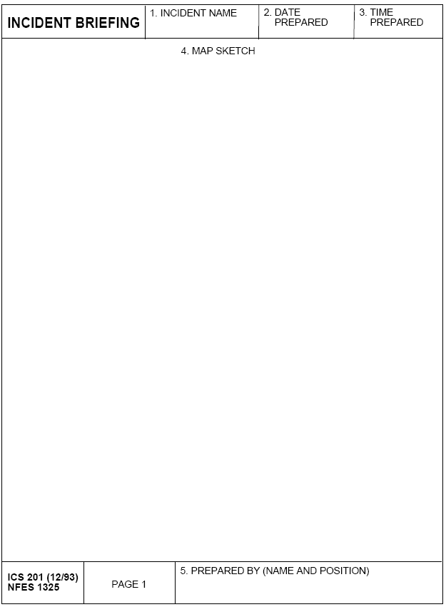
ICS-201 (p. 1)
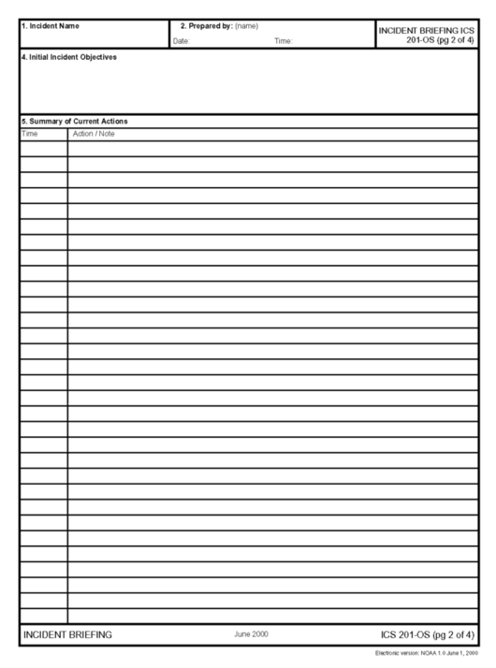
ICS-201 (p. 2)
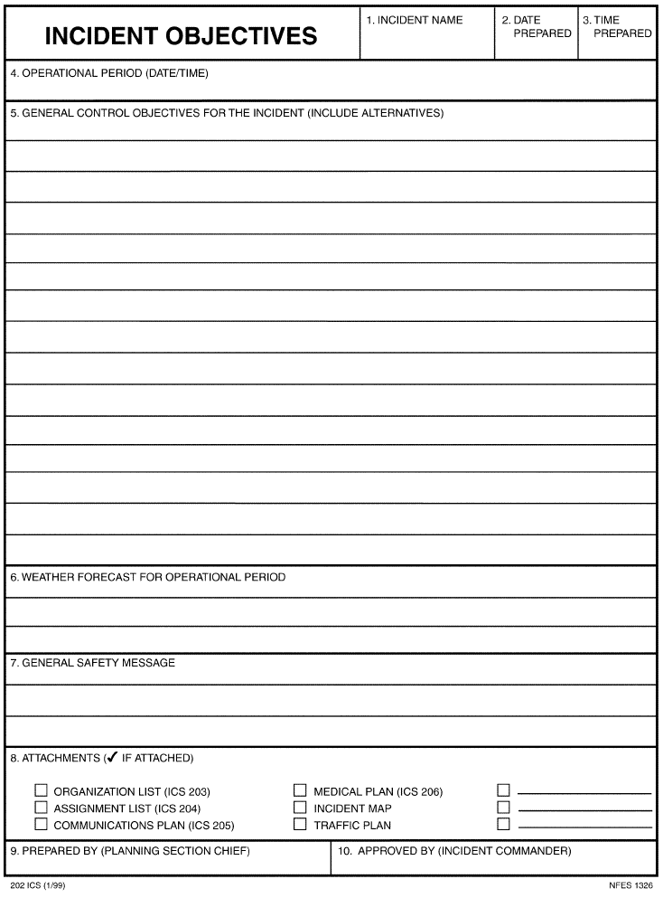
ICS-202
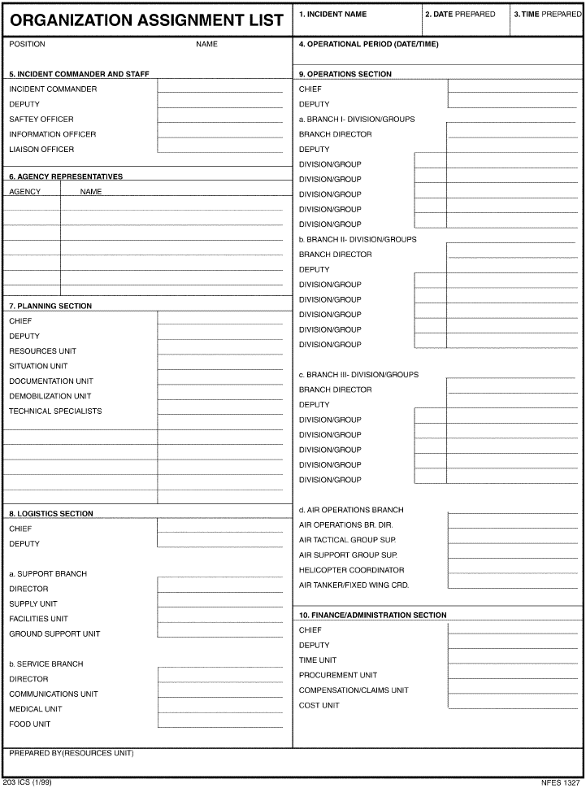
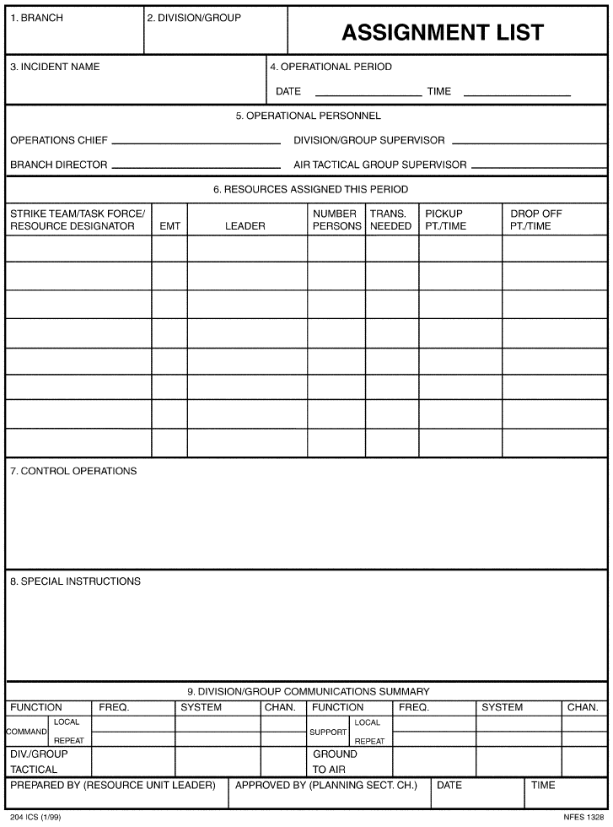
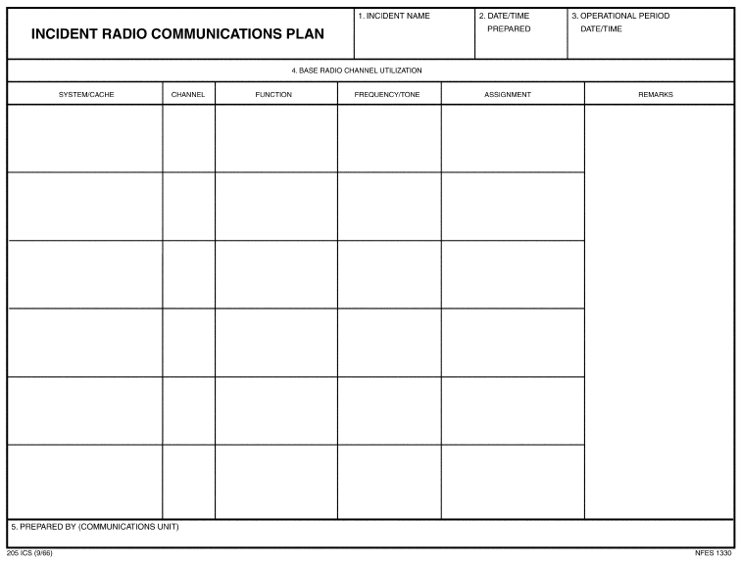

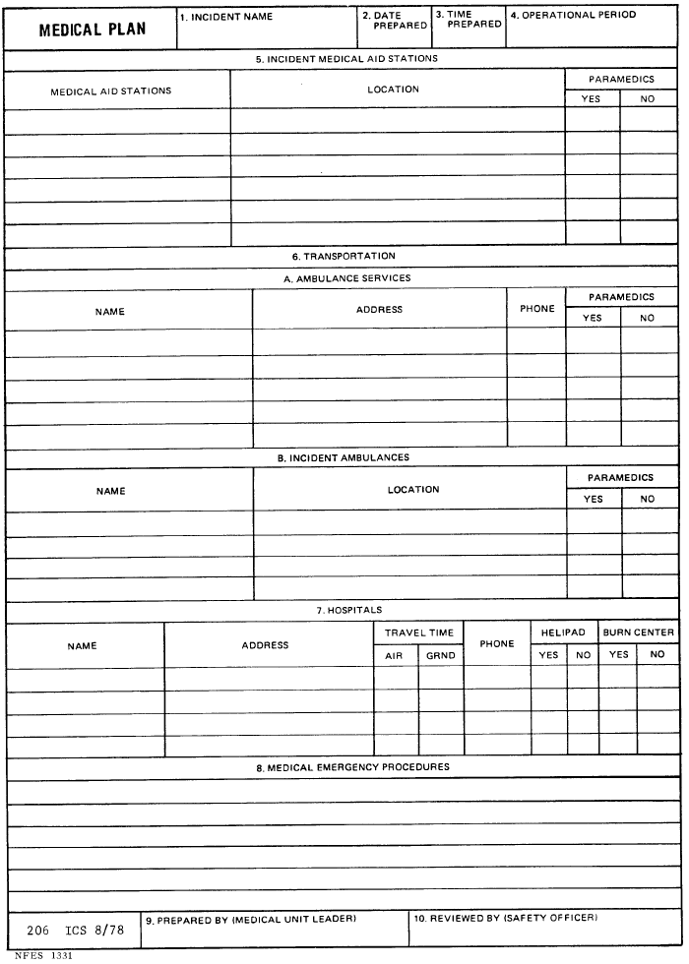
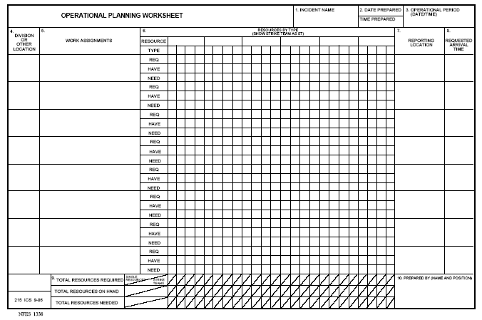

Appendix B
NIMS - National Incident Management Resource Typing System

A. PURPOSE.
This appendix provides additional information regarding the national equipment typing system specified in Chapter IV of this document.

B. RESPONSIBILITIES.
The NIMS Integration Center described in Chapter VII has the overall responsibility for ongoing development and refinement of various NIMS activities and programs. Under its auspices, the National Resource Management Working Group, chaired by the Emergency Preparedness and Response Directorate of the Department of Homeland Security, is responsible for establishing a national resource typing protocol. The NIMS resource typing protocol is based on inputs from representatives from various Federal agencies and departments and private organizations, as well as representatives of State and local emergency management; law enforcement; firefighting and emergency medical services; public health; public works; and other entities with assigned responsibilities under the Federal Response Plan and the National Response Plan. Federal, State, local, and tribal authorities should use the national typing protocol when inventorying and managing resources to promote common interoperability and integration.

C. ELEMENTS OF THE NATIONAL TYPING PROTOCOL.
The resource typing protocol provided by the NIMS describes resources using category, kind, components, metrics, and type data. The following data definitions will be used:
1. Resource
For purposes of typing, resources consist of personnel, teams, facilities, supplies, and major items of equipment available for assignment to or use during incidents. Such resources may be used in tactical support or supervisory capacities at an incident site or EOC. Their descriptions include category, kind, components, metrics, and type.
- Category
A category is the function for which a resource would be most useful. Table B-1 briefly describes the categories used in the national resource typing protocol.
Category | Purpose

Transportation | To assist Federal agencies, State and local governments, and voluntary organizations requiring transportation to perform incident management missions following a major disaster or emergency; to coordinate incident management operations and restoration of the transportation infrastructure

Communications | To provide communications support for Federal, State, local, and tribal incident management efforts

Public works and engineering | To assist those engaged in lifesaving, life-sustaining, damage mitigation, and recovery operations following a major disaster or emergency by providing technical advice, evaluation, and engineering services; by contracting for construction management and inspection and for the emergency repair of water and wastewater treatment facilities; supplying potable water and ice and emergency power; and arranging for needed real estate.

Firefighting | To detect and suppress urban, suburban, and rural fires.

Information and planning | To collect, analyze, process, and disseminate information about a potential or actual disaster or emergency to facilitate overall activities in providing assistance to support planning and decision-making.

Law enforcement and security | To provide law enforcement assistance during response and recovery operations; to assist with site security and investigation.

Mass care | To support efforts to meet the mass care needs of disaster victims including delivering such services as supplying victims with shelter, feeding, and emergency first aid; supplying bulk distribution of emergency relief supplies; and collecting information to and for a disaster welfare information system designed to report on victim status and assist in reuniting families.

Resource management | To provide operational assistance for incident management operations.

Health and medical | To provide assistance to supplement local resources in meeting public health and medical care needs following a disaster or emergency or during a potential developing medical situation.

Search and rescue | To provide specialized lifesaving assistance in the event of a disaster or emergency, including locating, extricating, and providing on-site medical treatment to victims trapped in collapsed structures.

Hazardous materials response | To support the response to an actual or potential discharge and/or release of hazardous materials.

Food and water | To identify, secure, and arrange for the transportation of safe food and water to affected areas during a disaster or emergency.

Energy | To help restore energy systems following a disaster or emergency

Public information | To contribute to the well-being of the community following a disaster by disseminating accurate, consistent, timely, and easy-to-understand information; to gather and disseminate information about disaster response and recovery process.

Animals and agricultural issues | To coordinate activities responding to an agricultural disaster and/or when the health or care of animals is at issue.

Volunteers and donations | To support the management of unsolicited goods and unaffiliated volunteers, and to help establish a system for managing and controlling donated goods and services

Table B-1—Categories Used in the National Resource Typing System

- Kind
Kind refers to broad classes that characterize like resources, such as teams, personnel, equipment, supplies, vehicles, and aircraft.
- Components
Resources can comprise multiple components. For example, an engine company may be listed as having the eight components shown in Table B-2.
(1) Pump | (5) Water tank

(2) Hose 2 __" | (6) Ladder

(3) Hose 1__" | (7) Master Stream

(4) Hose 1" | ((8) Personnel

Table B-2—Example of a Resource with Multiple Components
(Fire Fighting Engine Company)

As another example, urban search and rescue (US&R) teams consist of two 31- person teams, four canines, and a comprehensive equipment cache. The cache is divided into five separate, color-coded elements and is stored in containers that meet specific requirements.
5. Metrics
Metrics are measurement standards. The metrics used will differ depending on the kind of resource being typed. The mission envisioned determines the specific metric selected. The metric must be useful in describing a resource’s capability to support the mission. As an example, one metric for a disaster medical assistance team is the number of patients it can care for per day. Likewise, an appropriate metric for a hose might be the number of gallons of water per hour that can flow through it. Metrics should identify capability and/or capacity.
6. Type
Type refers to the level of resource capability. Assigning the Type I label to a resource implies that it has a greater level of capability than a Type II of the same resource (for example, due to its power, size, or capacity), and so on to Type IV. Typing provides managers with additional information to aid the selection and best use of resources. In some cases, a resource may have less than or more than four types; in such cases, either additional types will be identified, or the type will be described as “not applicable.” The type assigned to a resource or a component is based on a minimum level of capability described by the identified metric(s) for that resource. For example, the U.S. Coast Guard has typed oil skimmers based on barrels per day, as outlined below in Table B-3:
Type I | 9,600 bbls/day | Type III | 480 bbls/day

Type II | 2,880 bbls/day | Type IV | N/A

7. Additional Information
The national resource typing protocol will also provide the capability to use additional information that is pertinent to resource decision-making. For example, if a particular set of resources can only be released to support an incident under particular authorities or laws, the protocol should provide the ability for resource managers to understand such limitations.

D. EXAMPLE OF A RESOURCE FOR WHICH TYPING HAS BEEN COMPLETED
As an illustration of how the national equipment typing system is used, Figure B-4 is an example of a resource that has been completely typed, an urban search and rescue task force.

Resource: US&R Task Forces
Category: Search & Rescue (ESF 9)
Kind: Team
Minimum Capabilities (Component) | Minimum Capabilities  (Metric) | Type I | Type II | Type III | Type IV | Other
Personnel | Number of People per Response | 70-person response. | 28-person response.
Personnel | Training | NFPA 1670 Technician Level in area of specialty. Support personnel at Operations Level. | NFPA 1670 Technician Level in area of specialty. Support personnel at Operations Level.
Personnel | Areas of Specialization | High angle rope rescue (including highline systems); confined space rescue (permit required); Advanced Life Support (ALS) intervention; communications; WMD/HM operations; defensive water rescue. | Light frame construction and basic rope rescue operations; ALS intervention; HazMat conditions; communications; and trench and excavation rescue.
Personnel | Sustained Operations | 24-hour S&R operations. Self-sufficient for first 72 hours. | 12-hour S&R operations. Self-sufficient for first 72 hours.
Personnel | Organization | Multidisciplinary organization of Command, Search, Rescue, Medical, HazMat, Logistics, and Planning. | Multidisciplinary organization of Command, Search, Rescue, Medical, HazMat, Logistics, and Planning.
Equipment | Sustained Operations | Potential mission duration of up to 10 days. | Potential mission duration of up to 10 days.
Equipment | Rescue Equipment | Pneumatic Powered Tools, Electric Powered Tools, Hydraulic Powered Tools, Hand Tools, Electrical, Heavy Rigging, Technical Rope, Safety. | Pneumatic Powered Tools, Electric Powered Tools, Hydraulic Powered Tools, Hand Tools, Electrical, Heavy Rigging, Technical Rope, Safety.
Equipment | Medical Equipment | Antibiotics/ Antifungals, Patient Comfort Medication, Pain Medications, Sedatives/Anesthetics/Paralytics, Steroids, IV Fluids/Volume, Immunizations/Immune Globulin, Canine Treatment, Basic Airway, Intubation, Eye Care Supplies, IV Access/Administration, Patient Assessment Care, Patient Immobilization/Extrication, Patient/PPE, Skeletal Care, Wound Care, Patient Monitoring. | Antibiotics/Antifungals, Patient Comfort Medication, Pain Medications, Sedatives/ Anesthetics/Paralytics, Steroids, IV Fluids/Volume, Immunizations/Immune Globulin, Canine Treatment, Basic Airway, Intubation, Eye Care Supplies, IV Access/ Administration, Patient Assessment Care, Patient Immobilization/ Extrication, Patient/ PPE, Skeletal Care, Wound Care, Patient Monitoring.
Equipment | Technical Equipment | Structures Specialist Equip., Technical Information Specialist Equip., HazMat Specialist Equip., Technical Search Specialist Equip., Canine Search Specialist Equip. | Structures Specialist Equip., Technical Information Specialist Equip, HazMat Specialist Equip, Technical Search Specialist Equip., Canine Search Specialist Equip.
Equipment | Communications Equipment | Portable Radios, Charging Units, Telecommunications, Repeaters, Accessories, Batteries, Power Sources, Small Tools, Computer. | Portable Radios, Charging Units, Telecommunications, Repeaters, Accessories, Batteries, Power Sources, Small Tools, Computer.
Equipment | Logistics Equipment | Water/Fluids, Food, Shelter, Sanitation, Safety, Administrative Support, Personal Bag, Task Force Support, Cache Transportation/ Support, Base of Operations, Equipment Maintenance. | Water/Fluids, Food, Shelter, Sanitation, Safety, Administrative Support, Personal Bag, Task Force Support, Cache Transportation/ Support, Base of Operations, Equipment Maintenance.
Table B-4—Example of a Fully Typed Resource (Urban Search and Rescue Task Force)

Comments:
Federal asset. There are 28 FEMA US&R Task Forces, totally self-sufficient for the first 72 hours of a deployment, spread throughout the continental United States trained and equipped by FEMA to conduct physical search and rescue in collapsed buildings, provide emergency medical care to trapped victims, assess and control gas, electrical services and hazardous materials, and evaluate and stabilize damaged structures.

NIMS - Glossary of Key Terms

For the purposes of the NIMS, the following terms and definitions apply:

Agency: A division of government with a specific function offering a particular kind of assistance. In ICS, agencies are defined either as jurisdictional (having statutory responsibility for incident management) or as assisting or cooperating (providing resources or other assistance).

Agency Representative: A person assigned by a primary, assisting, or cooperating Federal, State, local, or tribal government agency or private entity that has been delegated authority to make decisions affecting that agency’s or organization’s participation in incident management activities following appropriate consultation with the leadership of that agency.

Area Command (Unified Area Command): An organization established (1) to oversee the management of multiple incidents that are each being handled by an ICS organization or (2) to oversee the management of large or multiple incidents to which several Incident Management Teams have been assigned. Area Command has the responsibility to set overall strategy and priorities, allocate critical resources according to priorities, ensure that incidents are properly managed, and ensure that objectives are met and strategies followed. Area Command becomes Unified Area Command when incidents are multi-jurisdictional. Area Command may be established at an emergency operations center facility or at some location other than an incident command post.

Assessment: The evaluation and interpretation of measurements and other information to provide a basis for decision-making.

Assignments: Tasks given to resources to perform within a given operational period that are based on operational objectives defined in the IAP.

Assistant: Title for subordinates of principal Command Staff positions. The title indicates a level of technical capability, qualifications, and responsibility subordinate to the primary positions. Assistants may also be assigned to unit leaders.

Assisting Agency: An agency or organization providing personnel, services, or other resources to the agency with direct responsibility for incident management. See also Supporting Agency.

Available Resources: Resources assigned to an incident, checked in, and available for a mission assignment, normally located in a Staging Area.

Branch: The organizational level having functional or geographical responsibility for major aspects of incident operations. A branch is organizationally situated between the section and the division or group in the Operations Section, and between the section and units in the Logistics Section. Branches are identified by the use of Roman numerals or by functional area.

Chain of Command: A series of command, control, executive, or management positions in hierarchical order of authority.

Check-In: The process through which resources first report to an incident. Check-in locations include the incident command post, Resources Unit, incident base, camps, staging areas, or directly on the site.

Chief: The ICS title for individuals responsible for management of functional sections: Operations, Planning, Logistics, Finance/Administration, and Intelligence (if established as a separate section).
Command: The act of directing, ordering, or controlling by virtue of explicit statutory, regulatory, or delegated authority.

Command Staff: In an incident management organization, the Command Staff consists of the Incident Command and the special staff positions of Public Information Officer, Safety Officer, Liaison Officer, and other positions as required, who report directly to the Incident Commander. They may have an assistant or assistants, as needed.

Common Operating Picture: A broad view of the overall situation as reflected by situation reports, aerial photography, and other information or intelligence. Communications Unit: An organizational unit in the Logistics Section responsible for providing communication services at an incident or an EOC. A Communications Unit may also be a facility (e.g., a trailer or mobile van) used to support an Incident Communications Center.

Cooperating Agency: An agency supplying assistance other than direct operational or support functions or resources to the incident management effort.

Coordinate: To advance systematically an analysis and exchange of information among principals who have or may have a need to know certain information to carry out specific incident management responsibilities.

Deputy: A fully qualified individual who, in the absence of a superior, can be delegated the authority to manage a functional operation or perform a specific task. In some cases, a deputy can act as relief for a superior and, therefore, must be fully qualified in the position. Deputies can be assigned to the Incident Commander, General Staff, and Branch Directors.

Dispatch: The ordered movement of a resource or resources to an assigned operational mission or an administrative move from one location to another.

Division: The partition of an incident into geographical areas of operation. Divisions are established when the number of resources exceeds the manageable span of control of the Operations Chief. A division is located within the ICS organization between the branch and resources in the Operations Section.

Emergency: Absent a Presidentially declared emergency, any incident(s), human-caused or natural, that requires responsive action to protect life or property. Under the Robert T. Stafford Disaster Relief and Emergency Assistance Act, an emergency means any occasion or instance for which, in the determination of the President, Federal assistance is needed to supplement State and local efforts and capabilities to save lives and to protect property and public health and safety, or to lessen or avert the threat of a catastrophe in any part of the United States.

Emergency Operations Centers (EOCs): The physical location at which the coordination of information and resources to support domestic incident management activities normally takes place. An EOC may be a temporary facility or may be located in a more central or permanently established facility, perhaps at a higher level of organization within a jurisdiction. EOCs may be organized by major functional disciplines (e.g., fire, law enforcement, and medical services), by jurisdiction (e.g., Federal, State, regional, county, city, tribal), or some combination thereof.

Emergency Operations Plan: The “steady-state” plan maintained by various jurisdictional levels for responding to a wide variety of potential hazards.

Emergency Public Information: Information that is disseminated primarily in anticipation of an emergency or during an emergency. In addition to providing situational information to the public, it also frequently provides directive actions required to be taken by the general public.

Emergency Response Provider: Includes Federal, State, local, and tribal emergency public safety, law enforcement, emergency response, emergency medical (including hospital emergency facilities), and related personnel, agencies, and authorities. See Section 2 (6), Homeland Security Act of 2002, Pub. L. 107-296, 116 Stat. 2135 (2002). Also known as Emergency Responder.

Evacuation: Organized, phased, and supervised withdrawal, dispersal, or removal of civilians from dangerous or potentially dangerous areas, and their reception and care in safe areas.

Event: A planned, nonemergency activity. ICS can be used as the management system for a wide range of events, e.g., parades, concerts, or sporting events.

Federal: Of or pertaining to the Federal Government of the United States of America.

Function: Function refers to the five major activities in ICS: Command, Operations, Planning, Logistics, and Finance/Administration. The term function is also used when describing the activity involved, e.g., the planning function. A sixth function, Intelligence, may be established, if required, to meet incident management needs.

General Staff: A group of incident management personnel organized according to function and reporting to the Incident Commander. The General Staff normally consists of the Operations Section Chief, Planning Section Chief, Logistics Section Chief, and Finance/Administration Section Chief.

Group: Established to divide the incident management structure into functional areas of operation. Groups are composed of resources assembled to perform a special function not necessarily within a single geographic division. Groups, when activated, are located between branches and resources in the Operations Section. (See Division.)

Hazard: Something that is potentially dangerous or harmful, often the root cause of an unwanted outcome.

Incident: An occurrence or event, natural or human-caused, that requires an emergency response to protect life or property. Incidents can, for example, include major disasters, emergencies, terrorist attacks, terrorist threats, wildland and urban fires, floods, hazardous materials spills, nuclear accidents, aircraft accidents, earthquakes, hurricanes, tornadoes, tropical storms, war-related disasters, public health and medical emergencies, and other occurrences requiring an emergency response.

Incident Action Plan: An oral or written plan containing general objectives reflecting the overall strategy for managing an incident. It may include the identification of operational resources and assignments. It may also include attachments that provide direction and important information for management of the incident during one or more operational periods.

Incident Command Post (ICP): The field location at which the primary tactical-level, on-scene incident command functions are performed. The ICP may be collocated with the incident base or other incident facilities and is normally identified by a green rotating or flashing light.

Incident Command System (ICS): A standardized on-scene emergency management construct specifically designed to provide for the adoption of an integrated organizational structure that reflects the complexity and demands of single or multiple incidents, without being hindered by jurisdictional boundaries. ICS is the combination of facilities, equipment, personnel, procedures, and communications operating within a common organizational structure, designed to aid in the management of resources during incidents. It is used for all kinds of emergencies and is applicable to small as well as large and complex incidents. ICS is used by various jurisdictions and functional agencies, both public and private, to organize field-level incident management operations.

Incident Commander (IC): The individual responsible for all incident activities, including the development of strategies and tactics and the ordering and the release of resources. The IC has overall authority and responsibility for conducting incident operations and is responsible for the management of all incident operations at the incident site.

Incident Management Team (IMT): The IC and appropriate Command and General Staff personnel assigned to an incident.

Incident Objectives: Statements of guidance and direction necessary for selecting appropriate strategy(s) and the tactical direction of resources. Incident objectives are based on realistic expectations of what can be accomplished have been effectively deployed. Incident objectives must be achievable and measurable, yet flexible enough to allow strategic and tactical alternatives.

Initial Action: The actions taken by those responders first to arrive at an incident site.
Initial Response: Resources initially committed to an incident.

Intelligence Officer: The intelligence officer is responsible for managing internal information, intelligence, and operational security requirements supporting incident management activities. These may include information security and operational security activities, as well as the complex task of ensuring that sensitive information of all types
(e.g., classified information, law enforcement sensitive information, proprietary information, or export-controlled information) is handled in a way that not only safeguards the information, but also ensures that it gets to those who need access to it to perform their missions effectively and safely.

Joint Information Center (JIC): A facility established to coordinate all incident-related public information activities. It is the central point of contact for all news media at the scene of the incident. Public information officials from all participating agencies should collocate at the JIC.

Joint Information System (JIS): Integrates incident information and public affairs into a cohesive organization designed to provide consistent, coordinated, timely information during crisis or incident operations. The mission of the JIS is to provide a structure and system for developing and delivering coordinated interagency messages; developing, recommending, and executing public information plans and strategies on behalf of the IC; advising the IC concerning public affairs issues that could affect a response effort; and controlling rumors and inaccurate information that could undermine public confidence in the emergency response effort.

Jurisdiction: A range or sphere of authority. Public agencies have jurisdiction at an incident related to their legal responsibilities and authority. Jurisdictional authority at an incident can be political or geographical (e.g., city, county, tribal, State, or Federal boundary lines) or functional (e.g., law enforcement, public health).

Liaison: A form of communication for establishing and maintaining mutual understanding and cooperation.

Liaison Officer: A member of the Command Staff responsible for coordinating with representatives from cooperating and assisting agencies.

Local Government: A county, municipality, city, town, township, local public authority, school district, special district, intrastate district, council of governments (regardless of whether the council of governments is incorporated as a nonprofit corporation under State law), regional or interstate government entity, or agency or instrumentality of a local government; an Indian tribe or authorized tribal organization, or in Alaska a Native village or Alaska Regional Native Corporation; a rural community, unincorporated town or village, or other public entity. See Section 2 (10), Homeland Security Act of 2002, Pub. L. 107-296, 116 Stat. 2135 (2002).

Logistics: Providing resources and other services to support incident management. Logistics Section: The section responsible for providing facilities, services, and material support for the incident.

Major Disaster: As defined under the Robert T. Stafford Disaster Relief and Emergency Assistance Act (42 U.S.C. 5122), a major disaster is any natural catastrophe (including any hurricane, tornado, storm, high water, wind-driven water, tidal wave, tsunami, earthquake, volcanic eruption, landslide, mudslide, snowstorm, or drought), or, regardless of cause, any fire, flood, or explosion, in any part of the United States, which in the determination of the President causes damage of sufficient severity and magnitude to warrant major disaster assistance under this Act to supplement the efforts and available resources of States, tribes, local governments, and disaster relief organizations in alleviating the damage, loss, hardship, or suffering caused thereby.

Management by Objective: A management approach that involves a four-step process for achieving the incident goal. The Management by Objectives approach includes the following: establishing overarching objectives; developing and issuing assignments, plans, procedures, and protocols; establishing specific, measurable objectives for various incident management functional activities and directing efforts to fulfill them, in support of defined strategic objectives; and documenting results to measure performance and facilitate corrective action.
Mitigation: The activities designed to reduce or eliminate risks to persons or property or to lessen the actual or potential effects or consequences of an incident. Mitigation measures may be implemented prior to, during, or after an incident. Mitigation measures are often informed by lessons learned from prior incidents. Mitigation involves ongoing actions to reduce exposure to, probability of, or potential loss from hazards. Measures may include zoning and building codes, floodplain buyouts, and analysis of hazard- related data to determine where it is safe to build or locate temporary facilities. Mitigation can include efforts to educate governments, businesses, and the public on measures they can take to reduce loss and injury.

Mobilization: The process and procedures used by all organizations—Federal, State, local, and tribal—for activating, assembling, and transporting all resources that have been requested to respond to or support an incident.

Multiagency Coordination Entity: A multiagency coordination entity functions within a broader multiagency coordination system. It may establish the priorities among incidents and associated resource allocations, deconflict agency policies, and provide strategic guidance and direction to support incident management activities.

Multiagency Coordination Systems: Multiagency coordination systems provide the architecture to support coordination for incident prioritization, critical resource allocation, communications systems integration, and information coordination. The components of multiagency coordination systems include facilities, equipment, emergency operation centers (EOCs), specific multiagency coordination entities, personnel, procedures, and communications. These systems assist agencies and organizations to fully integrate the subsystems of the NIMS.

Multijurisdictional Incident: An incident requiring action from multiple agencies that each have jurisdiction to manage certain aspects of an incident. In ICS, these incidents will be managed under Unified Command.

Mutual-Aid Agreement: Written agreement between agencies and/or jurisdictions that they will assist one another on request, by furnishing personnel, equipment, and/or expertise in a specified manner.

National: Of a nationwide character, including the Federal, State, local, and tribal aspects of governance and polity.

National Disaster Medical System: A cooperative, asset-sharing partnership between the Department of Health and Human Services, the Department of Veterans Affairs, the Department of Homeland Security, and the Department of Defense. NDMS provides resources for meeting the continuity of care and mental health services requirements of the Emergency Support Function 8 in the Federal Response Plan.

National Incident Management System: A system mandated by HSPD-5 that provides a consistent nationwide approach for Federal, State, local, and tribal governments; the private-sector, and nongovernmental organizations to work effectively and efficiently together to prepare for, respond to, and recover from domestic incidents, regardless of cause, size, or complexity. To provide for interoperability and compatibility among Federal, State, local, and tribal capabilities, the NIMS includes a core set of concepts, principles, and terminology. HSPD-5 identifies these as the ICS; multiagency coordination systems; training; identification and management of resources (including systems for classifying types of resources); qualification and certification; and the collection, tracking, and reporting of incident information and incident resources. National Response Plan: A plan mandated by HSPD-5 that integrates Federal domestic prevention, preparedness, response, and recovery plans into one all-discipline, all-hazards plan.

Nongovernmental Organization: An entity with an association that is based on interests of its members, individuals, or institutions and that is not created by a government, but may work cooperatively with government. Such organizations serve a public purpose, not a private benefit. Examples of NGOs include faith-based charity organizations and the American Red Cross.

Operational Period: The time scheduled for executing a given set of operation actions, as specified in the Incident Action Plan. Operational periods can be of various lengths, although usually not over 24 hours.

Operations Section: The section responsible for all tactical incident operations. In ICS, it normally includes subordinate branches, divisions, and/or groups.

Personnel Accountability: The ability to account for the location and welfare of incident personnel. It is accomplished when supervisors ensure that ICS principles and processes are functional and that personnel are working within established incident management guidelines.

Planning Meeting: A meeting held as needed prior to and throughout the duration of an incident to select specific strategies and tactics for incident control operations and for service and support planning. For larger incidents, the planning meeting is a major element in the development of the Incident Action Plan (IAP).

Planning Section: Responsible for the collection, evaluation, and dissemination of operational information related to the incident, and for the preparation and documentation of the IAP. This section also maintains information on the current and forecasted situation and on the status of resources assigned to the incident.

Preparedness: The range of deliberate, critical tasks and activities necessary to build, sustain, and improve the operational capability to prevent, protect against, respond to, and recover from domestic incidents. Preparedness is a continuous process. Preparedness involves efforts at all levels of government and between government and private-sector and nongovernmental organizations to identify threats, determine vulnerabilities, and identify required resources. Within the NIMS, preparedness is operationally focused on establishing guidelines, protocols, and standards for planning, training and exercises, personnel qualification and certification, equipment certification, and publication management.

Preparedness Organizations: The groups and fora that provide interagency coordination for domestic incident management activities in a nonemergency context. Preparedness organizations can include all agencies with a role in incident management, for prevention, preparedness, response, or recovery activities. They represent a wide variety of committees, planning groups, and other organizations that meet and coordinate to ensure the proper level of planning, training, equipping, and other preparedness requirements within a jurisdiction or area.

Prevention: Actions to avoid an incident or to intervene to stop an incident from occurring. Prevention involves actions to protect lives and property. It involves applying intelligence and other information to a range of activities that may include such countermeasures as deterrence operations; heightened inspections; improved surveillance and security operations; investigations to determine the full nature and source of the threat; public health and agricultural surveillance and testing processes; immunizations, isolation, or quarantine; and, as appropriate, specific law enforcement operations aimed at deterring, preempting, interdicting, or disrupting illegal activity and apprehending potential perpetrators and bringing them to justice.

Private Sector: Organizations and entities that are not part of any governmental structure. It includes for-profit and not-for-profit organizations, formal and informal structures, commerce and industry, and private voluntary organizations (PVO). Processes: Systems of operations that incorporate standardized procedures, methodologies, and functions necessary to provide resources effectively and efficiently. These include resource typing, resource ordering and tracking, and coordination.

Public Information Officer: A member of the Command Staff responsible for interfacing with the public and media or with other agencies with incident-related information requirements.

Publications Management: The publications management subsystem includes materials development, publication control, publication supply, and distribution. The development and distribution of NIMS materials is managed through this subsystem. Consistent documentation is critical to success, because it ensures that all responders are familiar with the documentation used in a particular incident regardless of the location or the responding agencies involved.

Qualification and Certification: This subsystem provides recommended qualification and certification standards for emergency responder and incident management personnel. It also allows the development of minimum standards for resources expected to have an interstate application. Standards typically include training, currency, experience, and physical and medical fitness.
Reception Area: This refers to a location separate from staging areas, where resources report in for processing and out-processing. Reception Areas provide accountability, security, situational awareness briefings, safety awareness, distribution of IAPs, supplies and equipment, feeding, and bed down.

Recovery: The development, coordination, and execution of service- and site-restoration plans; the reconstitution of government operations and services; individual, private- sector, nongovernmental, and public-assistance programs to provide housing and to promote restoration; long-term care and treatment of affected persons; additional measures for social, political, environmental, and economic restoration; evaluation of the incident to identify lessons learned; postincident reporting; and development of initiatives to mitigate the effects of future incidents.

Recovery Plan: A plan developed by a State, local, or tribal jurisdiction with assistance from responding Federal agencies to restore the affected area.

Resources: Personnel and major items of equipment, supplies, and facilities available or potentially available for assignment to incident operations and for which status is maintained. Resources are described by kind and type and may be used in operational support or supervisory capacities at an incident or at an EOC.

Resource Management: Efficient incident management requires a system for identifying available resources at all jurisdictional levels to enable timely and unimpeded access to resources needed to prepare for, respond to, or recover from an incident. Resource management under the NIMS includes mutual-aid agreements; the use of special Federal, State, local, and tribal teams; and resource mobilization protocols.

Resources Unit: Functional unit within the Planning Section responsible for recording the status of resources committed to the incident. This unit also evaluates resources currently committed to the incident, the effects additional responding resources will have on the incident, and anticipated resource needs.

Response: Activities that address the short-term, direct effects of an incident. Response includes immediate actions to save lives, protect property, and meet basic human needs. Response also includes the execution of emergency operations plans and of mitigation activities designed to limit the loss of life, personal injury, property damage, and other unfavorable outcomes. As indicated by the situation, response activities include applying intelligence and other information to lessen the effects or consequences of an incident; increased security operations; continuing investigations into nature and source of the threat; ongoing public health and agricultural surveillance and testing processes; immunizations, isolation, or quarantine; and specific law enforcement operations aimed at preempting, interdicting, or disrupting illegal activity, and apprehending actual perpetrators and bringing them to justice.

Safety Officer: A member of the Command Staff responsible for monitoring and assessing safety hazards or unsafe situations and for developing measures for ensuring personnel safety.

Section: The organizational level having responsibility for a major functional area of incident management, e.g., Operations, Planning, Logistics, Finance/Administration, and Intelligence (if established). The section is organizationally situated between the branch and the Incident Command.

Span of Control: The number of individuals a supervisor is responsible for, usually expressed as the ratio of supervisors to individuals. (Under the NIMS, an appropriate span of control is between 1:3 and 1:7.)

Staging Area: Location established where resources can be placed while awaiting a tactical assignment. The Operations Section manages Staging Areas.

State: When capitalized, refers to any State of the United States, the District of Columbia, the Commonwealth of Puerto Rico, the Virgin Islands, Guam, American Samoa, the Commonwealth of the Northern Mariana Islands, and any possession of the United States. See Section 2 (14), Homeland Security Act of 2002, Pub. L. 107-296, 116 Stat. 2135 (2002).

Strategic: Strategic elements of incident management are characterized by continuous long-term, high-level planning by organizations headed by elected or other senior officials. These elements involve the adoption of long-range goals and objectives, the setting of priorities; the establishment of budgets and other fiscal decisions, policy development, and the application of measures of performance or effectiveness.

Strike Team: A set number of resources of the same kind and type that have an established minimum number of personnel.

Strategy: The general direction selected to accomplish incident objectives set by the IC.

Supporting Technologies: Any technology that may be used to support the NIMS is included in this subsystem. These technologies include orthophoto mapping, remote automatic weather stations, infrared technology, and communications, among various others.

Task Force: Any combination of resources assembled to support a specific mission or operational need. All resource elements within a Task Force must have common communications and a designated leader.

Technical Assistance: Support provided to State, local, and tribal jurisdictions when they have the resources but lack the complete knowledge and skills needed to perform a required activity (such as mobile-home park design and hazardous material assessments).

Terrorism: Under the Homeland Security Act of 2002, terrorism is defined as activity that involves an act dangerous to human life or potentially destructive of critical infrastructure or key resources and is a violation of the criminal laws of the United States or of any State or other subdivision of the United States in which it occurs and is intended to intimidate or coerce the civilian population or influence a government or affect the conduct of a government by mass destruction, assassination, or kidnapping. See Section 2 (15), Homeland Security Act of 2002, Pub. L. 107-296, 116 Stat. 2135 (2002).

Threat: An indication of possible violence, harm, or danger.

Tools: Those instruments and capabilities that allow for the professional performance of tasks, such as information systems, agreements, doctrine, capabilities, and legislative authorities.

Tribal: Any Indian tribe, band, nation, or other organized group or community, including any Alaskan Native Village as defined in or established pursuant to the Alaskan Native Claims Settlement Act (85 stat. 688) [43 U.S.C.A. and 1601 et seq.], that is recognized as eligible for the special programs and services provided by the United States to Indians because of their status as Indians.

Type: A classification of resources in the ICS that refers to capability. Type 1 is generally considered to be more capable than Types 2, 3, or 4, respectively, because of size; power; capacity; or, in the case of incident management teams, experience and qualifications.

Unified Area Command: A Unified Area Command is established when incidents under an Area Command are multijurisdictional. (See Area Command.)

Unified Command: An application of ICS used when there is more than one agency with incident jurisdiction or when incidents cross political jurisdictions. Agencies work together through the designated members of the UC, often the senior person from agencies and/or disciplines participating in the UC, to establish a common set of objectives and strategies and a single IAP.

Unit: The organizational element having functional responsibility for a specific incident planning, logistics, or finance/administration activity.

Unity of Command: The concept by which each person within an organization reports to one and only one designated person. The purpose of unity of command is to ensure unity of effort under one responsible commander for every objective.

Volunteer: For purposes of the NIMS, a volunteer is any individual accepted to perform services by the lead agency, which has authority to accept volunteer services, when the individual performs services without promise, expectation, or receipt of compensation for services performed. See, e.g., 16 U.S.C. 742f(c) and 29 CFR 553.101.

NIMS - ACRONYMS
ALS | Advanced Life Support
DOC | Department Operations Center
EMAC | Emergency Management Assistance Compact
EOC | Emergency Operations Center
EOP | Emergency Operations Plan
FOG | Field Operations Guide
GIS | Geographic Information System
HAZMAT | Hazardous Material
HSPD-5 | Homeland Security Presidential Directive - 5
IAP | Incident Action Plan
IC | Incident Commander
ICP | Incident Command Post
ICS | Incident Command System
IC or UC | Incident Command or Unified Command
IMT | Incident Management Team
JIS | Joint Information System
JIC | Joint Information Center
LNO | Liaison Officer
NDMS | National Disaster Medical System
NGO | Nongovernmental Organization
NIMS | National Incident Management System
NRP | National Repsonse Plan
POLREP | Pollution Report
PIO | Public Information Officer
PVO | Private Voluntary Organizations
R&D | Research & Development
RESTAT | Resources Status
ROSS | Resource Ordering and Status System
SDO | Standards Development Organizations
SITREP | Situation Report
SO | Safety Officer
SOP | Standard Operating Procedure
UC | Unified Command
US&R | Urban Search and Rescue

